## horizontal line

UNDERLÖD

**───────**

An action RTS focused around kiting, area attacks and multitasking. Players buy the right balance of units, and upgrade them with items, building an army capable of defeating the challenging levels. Roguelike, with random items and full restart on death.

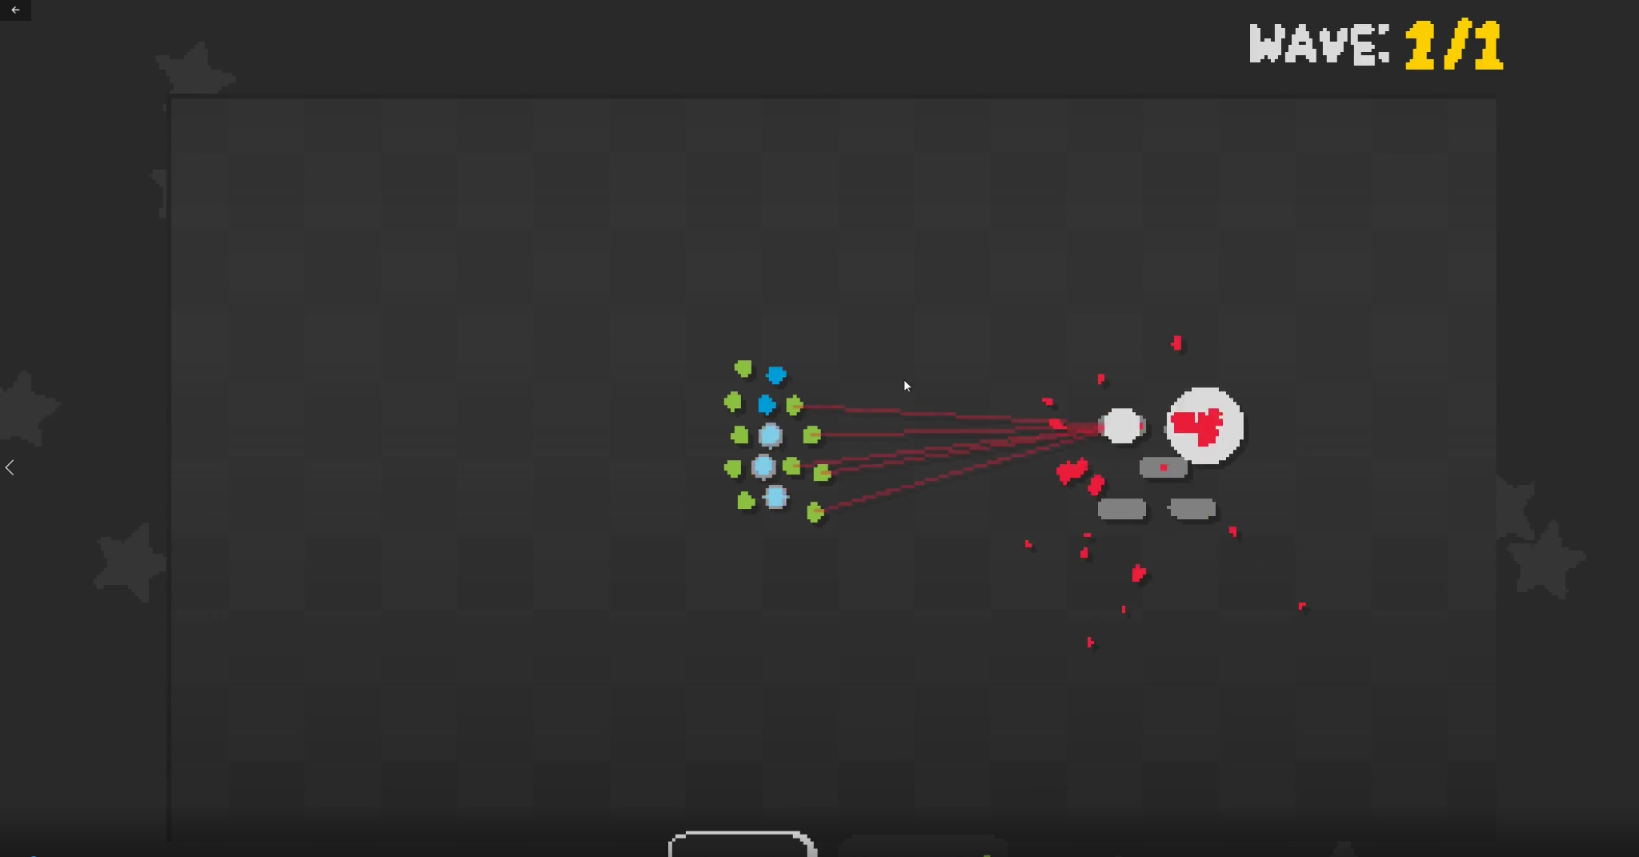

Game structure:

-alternates between combat rounds and buy phase

-control units with mouse and control groups on 1/2/3/4

-controls are designed for kiting and dodging AoE spells

-every 5/10 rounds is a boss round

-enemies scale between rounds and become increasingly dangerous, the player has to keep up with item synergy, unit composition, and target selection

Combat inspirations:

-Diablo 3 Belial (ground targeted attacks, warning circle before hit)

[Diablo III: Act 2 Final Boss Battle - Belial](https://www.youtube.com/watch?v=TQSd0LkzRcI&t=114s)

-WoW Heigan Safety Dance(ground targeted attacks, dodge in pattern)

[Heigan Safety Dance - Quick Guide](https://www.youtube.com/watch?v=wlXXmIcj_MY)

-Dota Primal Beast

[DOTA 2 BOSS BATTLES: PRIMAL BEAST - Aghanim's Labyrinth "The Continuum Conundrum"](https://www.youtube.com/watch?v=7qhuQ8UR0R4&t=65s)

-kiting in LoL/Dota

[how to kite in 40seconds](https://www.youtube.com/watch?v=94jY2mQ_Gyg&t=23s)

- bullet hell

[Monolith Gameplay (PC game)](https://www.youtube.com/watch?v=QLyAopq4q5c&t=404s)

[Hero Core trailer - Remar Games](https://www.youtube.com/watch?v=Cu_xdCHdSqg)

Buy round inspirations:

-Dota Underlords + spinoffs SNKRX/Just King

-shop has random unit/item choices

-tradeoff between spending+saving (interest on unspent gold)

-20 Minutes till Dawn

-multiplicative scaling between items

-different possible builds, enabled by what the shop gives you

Units:

-informed by WoW raids

-mix of healers/damage dealers/front liners

-focus on AoE abilities